CHAPTER 8: Forces, energy and motion

Worksheet 8.3

Acceleration
Answers
The velocities of two objects were recorded over ten-second time periods, as shown in the examples below.

Example: Gaining and losing speed
Time (s) | 0 | 1 | 2 | 3 | 4 | 5 | 6 | 7 | 8 | 9 | 10
Velocity  (m/s) | 0 | 2 | 4 | 6 | 8 | 10 | 12 | 11 | 10 | 9 | 8
1. (a) Use a spreadsheet application such as Excel to plot a line graph of this data.
(b) Format your graph. Ensure that the graph has a title and that each axis has a title and appropriate units. Use the graph to answer the following questions.
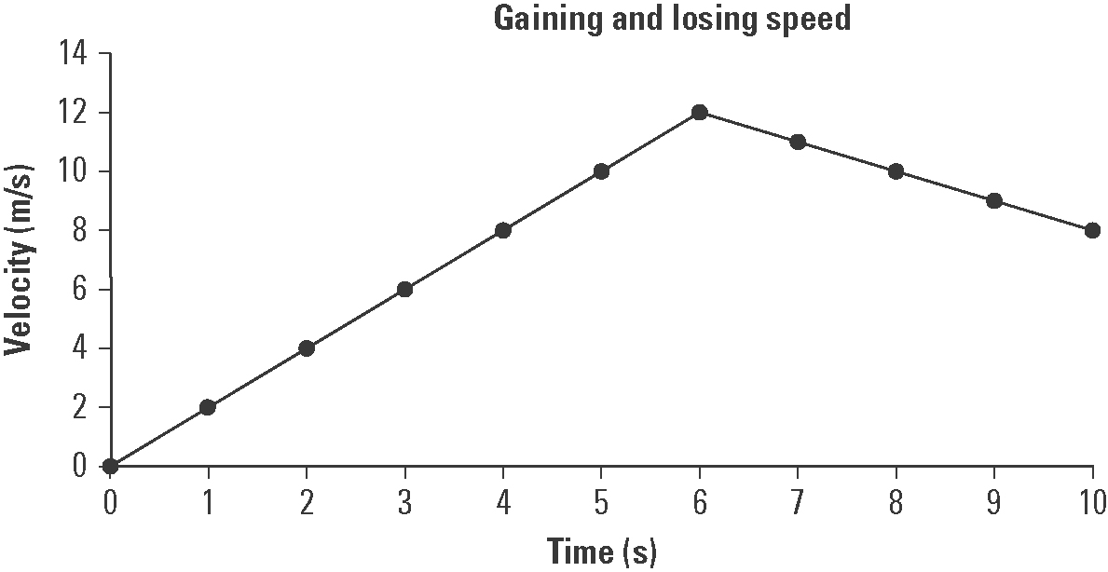

(c) Explain the shape of the graph.
The object accelerates uniformly for the first six seconds and then decelerates uniformly for the next four seconds.

(d) At the six second mark the object’s speed begins to decrease. If the object’s speed continues to decline at the same rate after ten seconds, at what time will its velocity be zero?
At t = 18 seconds its velocity will be zero as its velocity is decreasing by 1 m/s every second.

Example: Falling down
Time (s) | 0 | 1 | 2 | 3 | 4 | 5 | 6 | 7 | 8 | 9 | 10
Velocity  (m/s) | 0 | 9.8 | 19.6 | 29.4 | 39.2 | 49.0 | 58.8 | 68.6 | 78.4 | 88.2 | 98.0
2. (a) Examine the data table and determine the pattern in the data. Use this pattern to complete the table.
(b) Use a spreadsheet application such as Excel to plot a line graph of this data.
(c) Format your graph. Ensure that the graph has a title and that each axis has a title and appropriate units. Use the graph to answer the following questions.
CHAPTER 8: Forces, energy and motion

Worksheet 8.3

Page 2

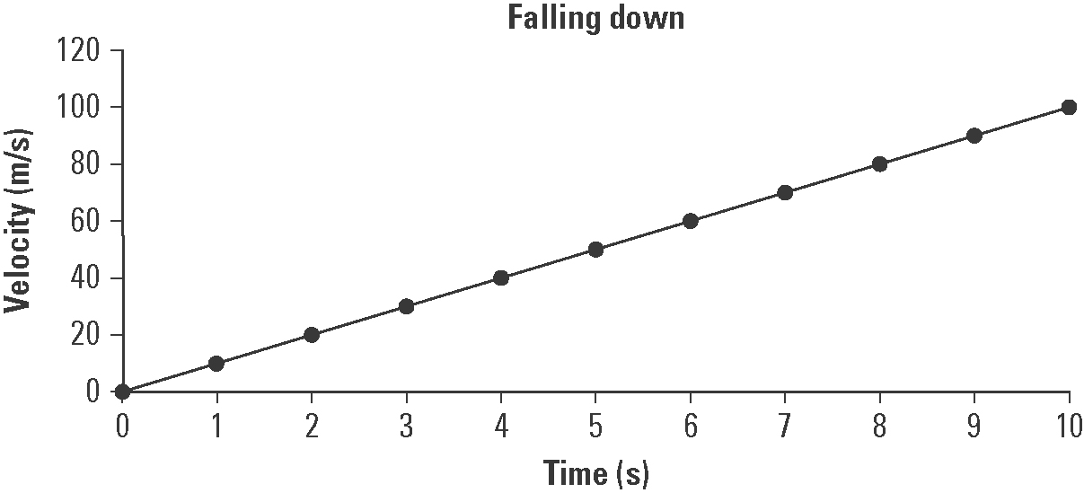

(d) Explain how this graph shows that falling due to gravity is an example of uniform acceleration.
The graph is linear with a constant slope. Thus, the falling object’s velocity is increasing at a uniform rate as would be expected for a body falling in a gravity field (as long as friction is absent or negligible).

(e) The slope of the graph is equal to the acceleration due to gravity. Determine the slope of the graph in m/s².
Slope = = = 9.8 m/s²

